Interstellar Orchestrator Software (IOS)

Software Architecture Design

Table of Contents

1 Signature Approval 3
2 Purpose 3
3 Scope 3
4 References 3
5 Definitions 3
6 Software Architecture 4
6.1 Software Overview 4
6.2 Physical Architecture 8
6.3 Logical Architecture 9
6.4 Security Architecture 18
6.5 Software Decomposition 20
7 SOUP 24
8 Release History 25

Signature Approval
Approval of this document shall be captured electronically in the Illumina Document Management System.

Purpose
This document provides a comprehensive architectural overview of the Interstellar Orchestrator Software (IOS), using a number of different architectural views to depict different aspects of the software.

Scope
This document describes the software architecture for Interstellar Orchestrator Software. It describes the various aspects of the Interstellar Orchestrator Software design that are architecturally significant. These elements and behaviors are fundamental for guiding the construction of the Interstellar Orchestrator Software and for understanding this product.
This Software Architecture Design (SAD) document is not intended to describe the detailed software architecture of the individual software components. Software architecture information is contained in the individual software component’s Software Design Documents (SDD).

References
Title | Reference Number
Procedure, Software Development Life Cycle | 15043593
Procedure, Product Security | 200045766
Work Instruction, Software Design | 1000000050713
Illumina Connected Insights SAD | 200019066
Automation Framework SAD | TBD
Sample Store Software SAD | TBD
Admin Console Local | TBD
DRAGEN Application Manager SAD | 200069599
Baymax SAD | TBD
Gaia SAD | TBD
DRAGEN v5 Server | TBD

Definitions
Refer to Regulatory and Illumina Glossary, 11317468 for all terms unless there are items particular to this document which are listed in the table below.

Term | Definition
Software Item | Per IEC 62304, a software item is defined as any identifiable part of a computer program.  A software item is composed of one or more software units or decomposable software items.
Software System | Per IEC 62304, integrated collection of software items organized to accomplish a specific function or set of functions
Software Unit | Per IEC 62304, a software item that is not sub-divided into other software items
SOUP | Software of Unknown Provenance
SDD | Software Detailed Design
On Prem Software | Software deployed in customers local lab network
AWS | Amazon Web services cloud infrastructure
Cloud | Software deployed in illumina managed cloud instances e.g. AWS
ICA | Illumina connected Analytics. Project that delivers the implementation of the cloud service platform (ICA)
DRAGEN Server | Dynamic Read Analysis for GENomics (DRAGEN). It's Illumina provided server which is used for performing on premises secondary & Tertiary Analysis of NGS (Next Generation Sequencing) data.

Software Architecture

Software Overview
The Interstellar Orchestrator Software (IOS) is a sample to answer solution developed to automate NGS workflows. Its core functionalities encompass sample, run, and workflow management, alongside integrated data analysis capabilities for secondary, tertiary analysis & reporting. IOS is built upon several major independently releasable Illumina software components including DRAGEN Applications, Illumina Connected Insights (ICI), and Illumina Connected Analytics (ICA) leveraging the AWS cloud platform for deployment. For local deployments (IOS local), a self-contained solution is available on the DRAGEN server.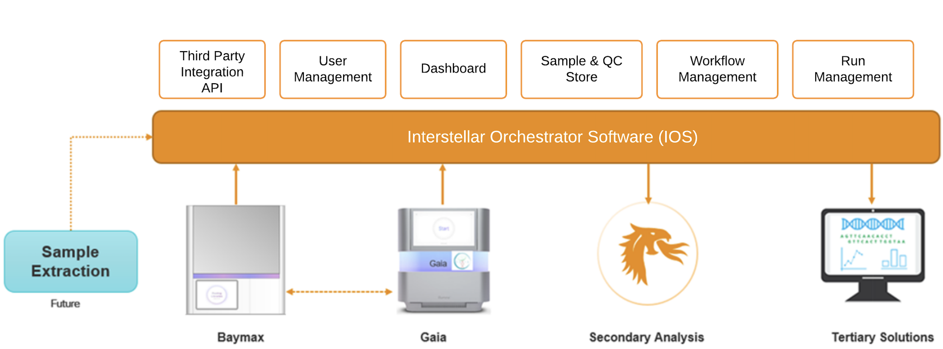

The Table below summarizes these major components
Name | Subsystem components | Description | Level of Concern
System Administration | Administration Console (Local) | Administration console package is the combination of services, user interface and third-party services which sets the on-premises infrastructure on the server.  It consists of below illumina developed services and user interfaces:  IAS is responsible for user management, workgroup, system settings and policies. It’s responsible for authentication and authorization of the system using a third-party service. All connected systems. This is a service accompanied by a UI service - Administration Console (IAC).  IAC provides a user interface which allows a privileged user to perform user management & assign roles, configure system policies and settings.  SUT service responsible for the software updates and installs through the user interface accessible to the privileged users of the system.  License Application Manager (LAM) service is responsible for managing the licenses required for the applications deployed on DRAGEN server. | Moderate
Authentication and Authorization | Gateway Service | Gateway service intercepts all the IOS application request and is responsible for managing the authentication of the application by delegating the auth and authorization request calls to IAS service. | Moderate
Local Backup Service | Cron Job of Kubernetes | A cron job which takes the backup of databases which will be used to recover the system in case of system failures in on premises environment. | Moderate
Run Management - | Run Management Service (RMS)  Genomic Sequencing Service (GSS)  RMS-UI | RMS is responsible for the run management of the system and stores the E2E run info, Sequencing to result info, Library prep run info and the overall run status.  RMS interacts with the GSS service to store and retrieve the Sequencing and Analysis info and all request from the sequencing system are intercepted by RMS and the runs which are ready for sequencing are routed to and served by GSS.  Run Planning UI service provides the interface to create, view and manage the runs of the system. | Moderate
Workflow Management | Workflow Management Service (WMS)  Automation  WMS-UI | Workflow Management service (WMS) is responsible for workflow installation, manages the state and status of predefined and custom workflows. It stores workflow configuration which includes Library prep, Sequencing, Analysis, QC and Tertiary Applications settings. The workflow configuration is provided in JSON format.  Automation Framework is illumina developed automation solution which is on prem and cloud compatible. It allows to automate the steps of the workflows when a condition is met. This framework will be used by WMS to trigger the automation steps post sequencing run.  WMS UI provides the interface for the users with privileges to perform the workflow management. | Moderate
Fleet Management | Device Management Service (DMS)  DMS-UI | DMS service is responsible for registering the IOS agents on the system, perform Auth and records the device information and state of the registered devices.  DMS UI provides the user interface for users to view the fleet details and status of the connected devices. | Moderate
Library Prep | Baymax Agent | Baymax Agent is a component which will be deployed on the Baymax instrument and is responsible for establishing the connection with IOS software based on the provided IP or hostname of the IOS application, once its Authenticated and connection approved by privileged users the connection will be established, and the instrument details and status will be sent to the IOS application. The Agent has capability to make synchronous and asynchronous message calls to the IOS application. This registers the library prep instrument to be part of the IOS fleet. One or more Baymax instrument with the agent can connect to a single instance of IOS application.  The agent works as an adapter/connector between the instrument software and IOS. The agents are auto updatable when enabled by the privileged user.
Sequencing | Gaia Agent | Gaia Agent is a component which will be deployed on the Sequencing instrument and is responsible for establishing the connection with IOS software based on the provided IP or hostname of the IOS application, once its Authenticated and connection approved by privileged users the connection will be established, and the instrument details and status will be sent to the IOS application. The Agent has capability to make synchronous and asynchronous message calls to the IOS application. This registers the sequencing instrument to be part of the IOS fleet. One or more Gaia instruments with the agent can connect to a single instance of IOS application.  The agent works as an adapter/connector between the instrument software and IOS. The agents are auto updatable when enabled by the privileged user.
Secondary Analysis | DRAGEN Application Manager (DAM)  DRAGEN Agent  DRAGEN APPS | DAM is a command line tool used for On DRAGEN server app & resource management, provides the execution environment for the DRAGEN secondary Applications built using Nextflow.  DRAGEN Agent is a component which is deployed on the DRAGEN server and is responsible for establishing the connection with IOS software based on the provided IP or hostname of the IOS application, once its Authenticated and connection approved by privileged users the connection will be established, and the server details and status will be sent to the IOS application. The DRAGEN Agent will read the secondary analysis jobs created by IOS software and perform the secondary analysis by invoking DAM cli commands and send asynchronous messages to the IOS application. Agent registers the DRAGEN server to be part of the IOS fleet. One or more DRAGEN servers with the DRAGEN agent can connect to a single instance of the IOS application. The agent works as an adapter/connector between the DRAGEN server and IOS. The agents are auto updatable when enabled by the privileged user.  DRAGEN secondary Apps are responsible for performing the secondary analysis of the samples. Apps are packaged as part of the IOS workflow. The on-premises apps are executable in DAM execution environment and ICA Apps are installed and executed under ICA execution environment. | Moderate
Tertiary Analysis | Illumina Connected Insights | Illumina Connected Insights (ICI) is responsible for performing the somatic tertiary analysis, report generation and provides user interface for case view, interpretation and report approval. Illumina Insights is integrated with the IOS application which automates the tertiary analysis and provides links between the IOS samples and ICI cases. Illumina connected Insights offers on premises and cloud-based solution. | Moderate
Data Management | External Storage (On Premises)  Illumina Connected Analytics (ICA) | IOS system allows privileged users to configure their own external/network NFS/SMB storage, which is used for storing library prep, sequencing, secondary, tertiary analysis data and IOS backed up data.  Illumina Connected Analytics delivers the implementation of the cloud service platform, that enables Cloud data management when IOS is deployed on cloud. | Moderate

Physical Architecture
Interstellar Orchestrator software is a web application software. For on premises solution, it’s deployable on a server. The application user interface is accessible remotely through the web browser using HTTPS protocol. The data files generated by the instruments are written on the customer provided external storage where the same storage is mounted on all the connected devices that are part of the IOS fleet. The data generated by the sequencing instruments is read by the secondary analysis application which processes the (.bcl) data and generates the variant (.vcf) files and writes to the mounted storage. The tertiary application reads the vcf data from the mounted storage which annotates the data & generates the reports.
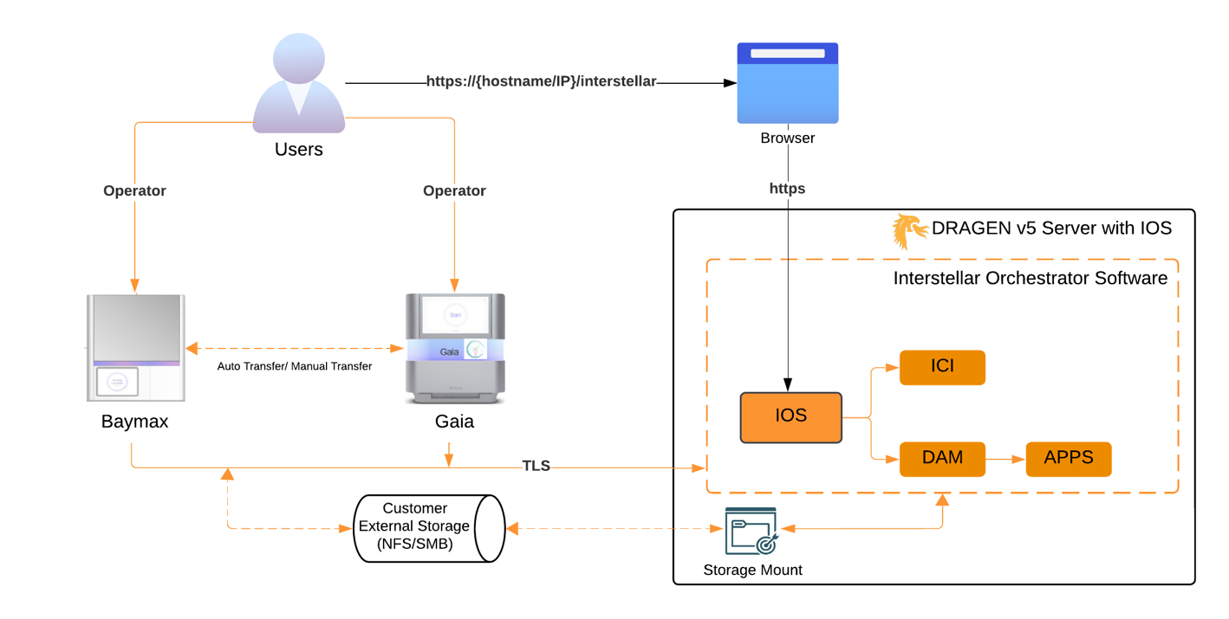

Logical Architecture

Logical Architecture – System view

Below diagram depicts the E2E system level architecture and outlines the software Items applicable to the IOS software and integration points.
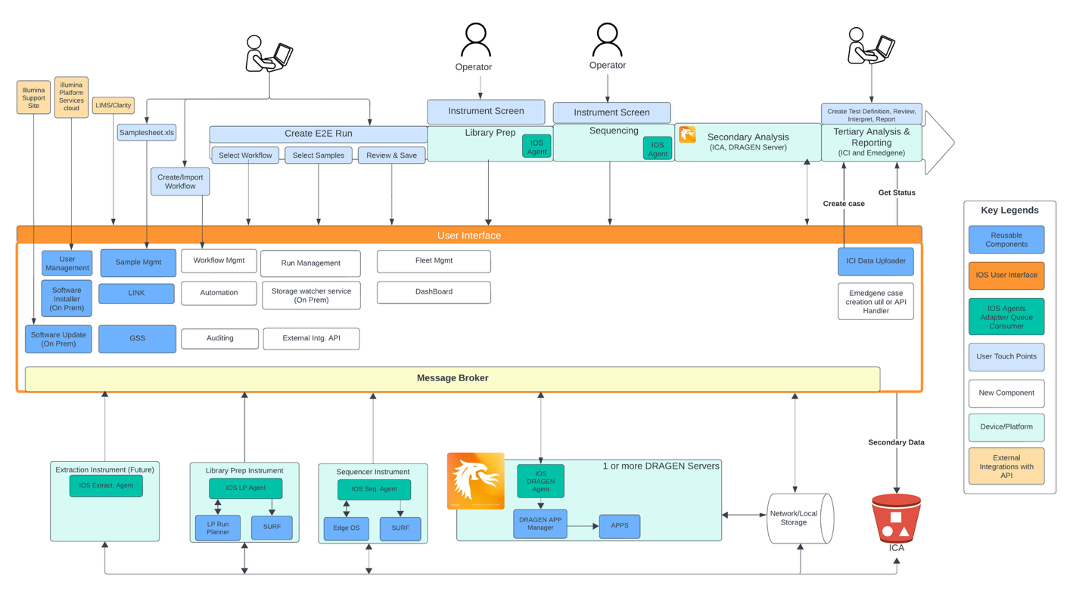

Logical Architecture – System Data Flow

Below diagram depicts the E2E system level data flow and external system integration points such as EHR and LIMS.

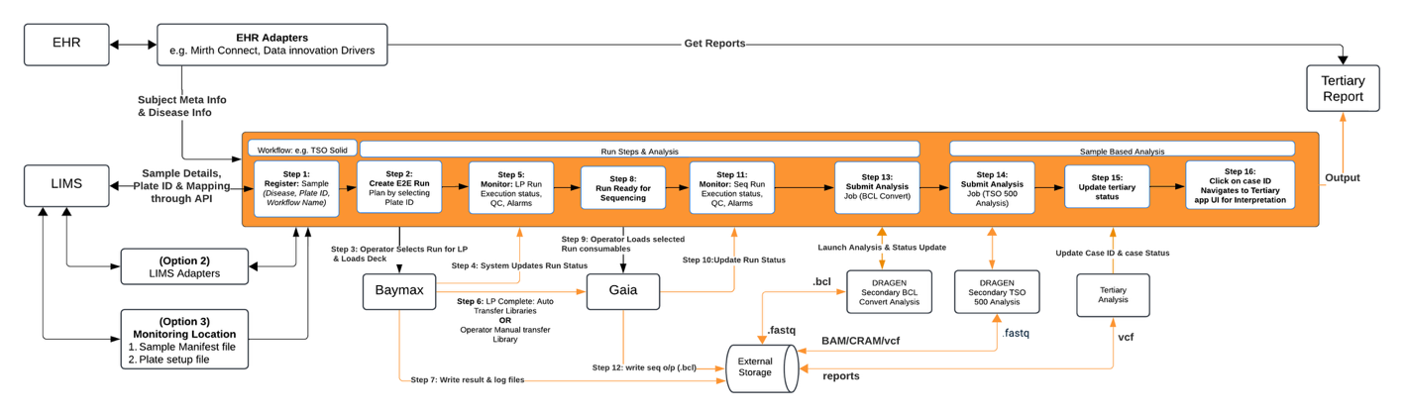

Logical Architecture – Deployment view of IOS on a DRAGEN server

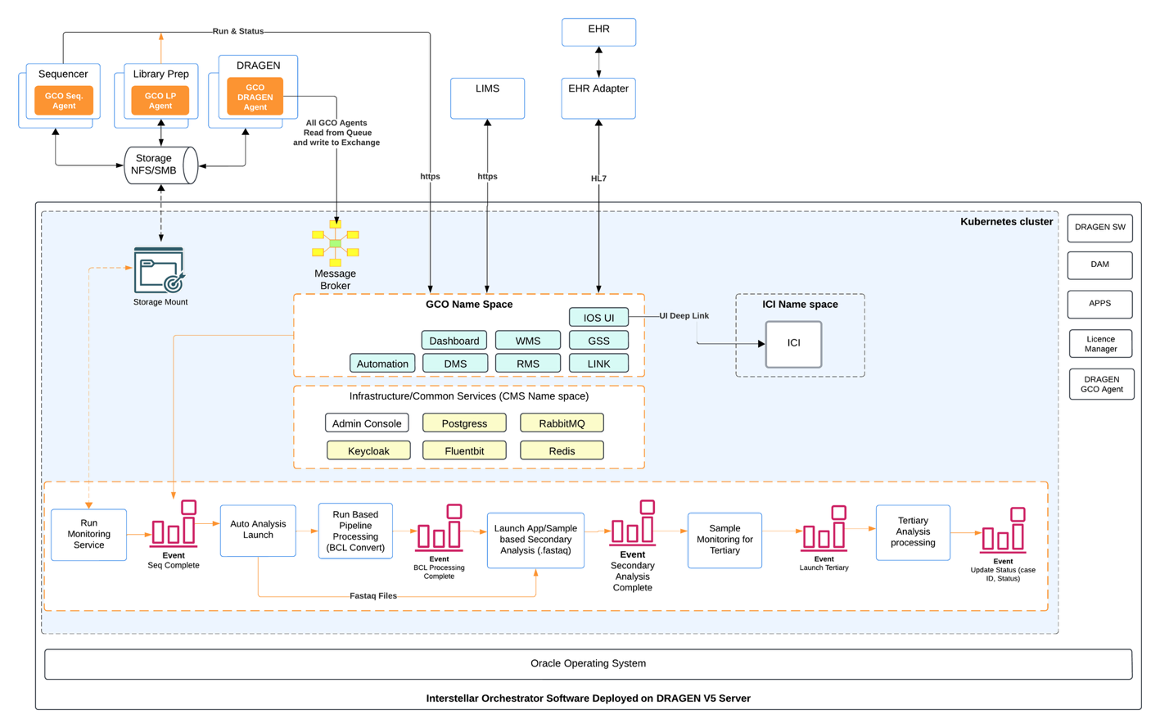

Logical Architecture – Workflow
Workflow configuration will carry the regulatory labelling of the workflow e.g. IVD/RUO. Each workflow configuration will consist of settings applicable to the workflow and is self-contained. A workflow will have a preconfigured state and settings which will define the actions a user can perform on a given workflow. Any changes performed on a workflow are auditable and will generate a new revision number. A workflow
Workflow configuration is of two types
- Preconfigured ready to use workflow with locked settings controlled by workflow configuration
- Workflow Templates which can be used by the labs to define their custom workflow within the predefined boundaries and configurable parameters specified by the templates.
A workflow consists of below settings
- Compatibility with the interstellar and instrument software version
- A predefined mandatory sample attributes required for secondary and Tertiary Analysis to reduce the additional touch points from the user
- A predefined specimen types as applicable to the workflow
- Library Prep settings with an ability to bundle the instrument recipe package and compatibility with instrument software version. It also holds the configuration of consumables required and their retention period after usage as applicable to Kit. E.g. Archival plate can be used for 3 months post run completion date.
- Sequencing settings with an ability to bundle the instrument recipe package and compatibility with instrument software version. It also holds the configuration of consumables required and their retention as applicable to kit.
- Analysis settings with the secondary analysis apps package bundled with it
- Tertiary Settings with the information of which application types are supported and ability to have a predefined Test definition association or bundle the whole test definition package and install to the tertiary
- QC settings with the applicable QC metrics list and threshold range and default value associated to the metric for QC Pass/Fail determination. QC settings can
- List of steps and each step of the workflow can have an automation script associated with.
Note: Recipe package is optional and if bundled with the workflow will be shared with the connected instrument type for installation. For details on installation process refer the software & workflow Installation section of this document.

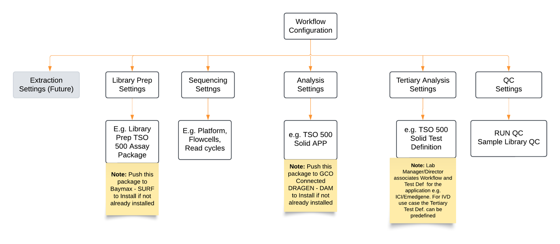

Logical Architecture – Sample Management
Interstellar Orchestrator software system will have a set of predefined reserved sample attributes on which the sample positive tracking, business logic, secondary and tertiary analysis processing is dependent on. System will have an ability which allows privileged customers to define their own custom attributes related to sample, subject and case. The attributes defined by customer will have an ability to categorize attributes as restricted for which only the privileged user will have access to. The attributes marked as privileged are encrypted using AES 256 algorithm and will be hidden or masked from the user interface view of non-privileged users. IOS will store all the sample meta data, positive sample tracking info, QC metrics and status in LINK database. Tertiary analysis solution will read the same data based on the sample ID available for the case creation which is processed by the Tertiary analysis monitoring tool developed by each tertiary application team. For a given Sample ID the tertiary analysis will update the case ID and case status back to the LINK database (diagram below shows the interaction between IOS, LINK and Tertiary Analysis more low-level details will be documented as part of SDD).
Interstellar Orchestrator software allows registration of the samples in the system using below 3 forms
- User interface
- Through third party systems using system exposed APIs
- By Monitoring external storage configured folder location

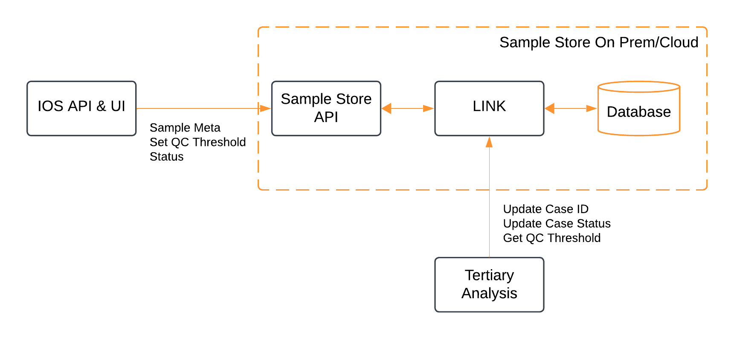

Logical Architecture – Run Management
Interstellar Orchestrator Software provides the Run Management capabilities such as view, create and monitor run status. Where a run plan is created by a user remotely using a web browser by accessing the IOS application. Run Management service depends on the Workflow Management service to get the details of workflow using which it guides user for the run creation flow.
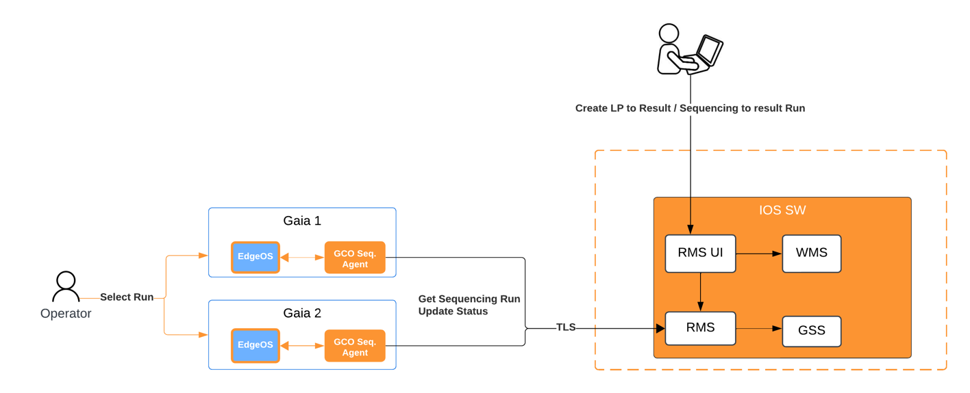

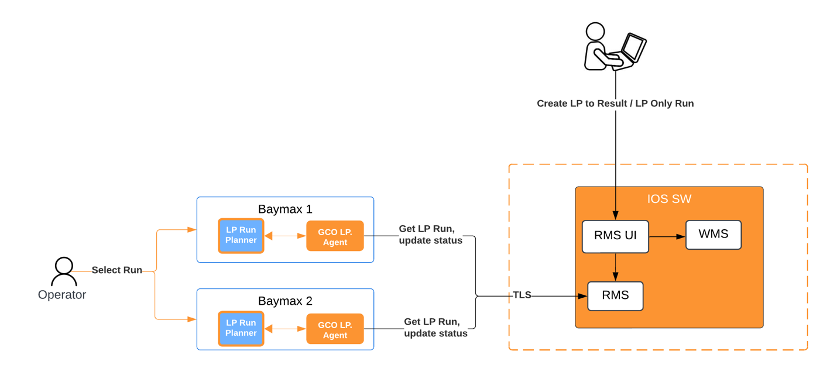

Logical Architecture – Secondary Analysis

Interstellar Orchestrator Software is responsible for creating analysis jobs and it submits the job to a messaging queue. The job creation is done by the automation script associated with the workflow entity. The agent running on the DRAGEN server polls the analysis job and takes a lock on the DRAGEN server by invoking the DAM command for the secondary analysis job processing. If lock for the analysis is successful the analysis is launched and an acknowledgement is sent back to the queue to remove the job from queue, in case of failure to acquire lock the job is retained in the queue for later processing. System will also have the priority queue capability and samples labeled as Priority sample will be prioritized over the other samples when scheduling the analysis jobs in queue.
The IOS will create analysis jobs as below
- For Demultiplexing (using BCL convert) a single job analysis which generates fastq files
- Post Demux step it creates jobs per sample with an ability to create jobs per workflow. This is configurable as part of the workflow Analysis settings
- If Control samples (Positive & NTC samples) are associated with the run, then control samples analysis is prioritized over the actual samples for processing.
- QC processing automation steps based on the workflow QC settings to determine the QC pass fail criteria.

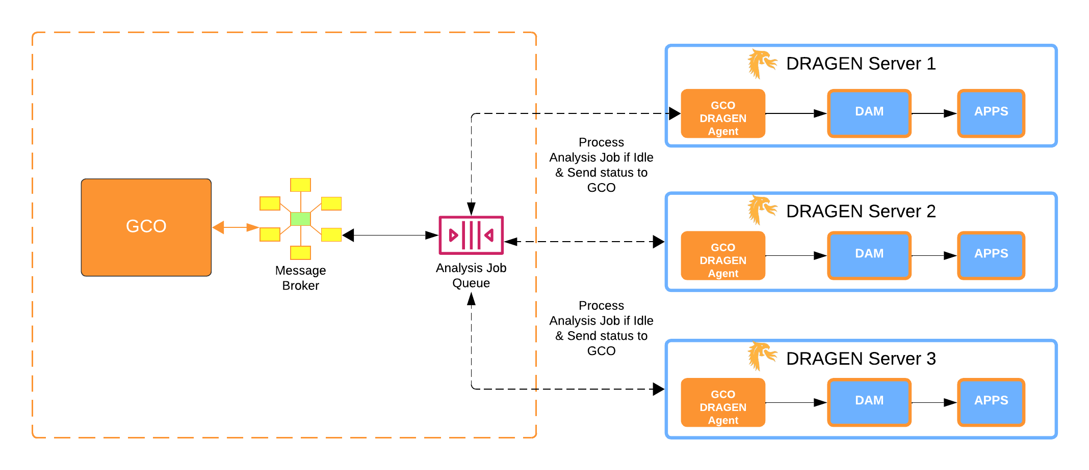

Logical Architecture – Tertiary Analysis
Interstellar software integrates with the Tertiary application software. It receives the updates to case and case updates through the LINK component. Both tertiary application and IOS are integrated with the LINK APIs. Below diagram outline the data flow process of IOS, secondary Analysis followed by tertiary and report generation using Tertiary Application UI. The data uploader is the ICI data uploader which is deployed on premises which monitors the configured network storage and ingest the cases automatically without a user touchpoint. IOS auto registers the path of the secondary analysis output for a workflow with the ICI application and it provides an interface to the users to associate the Test definition with the Workflow.

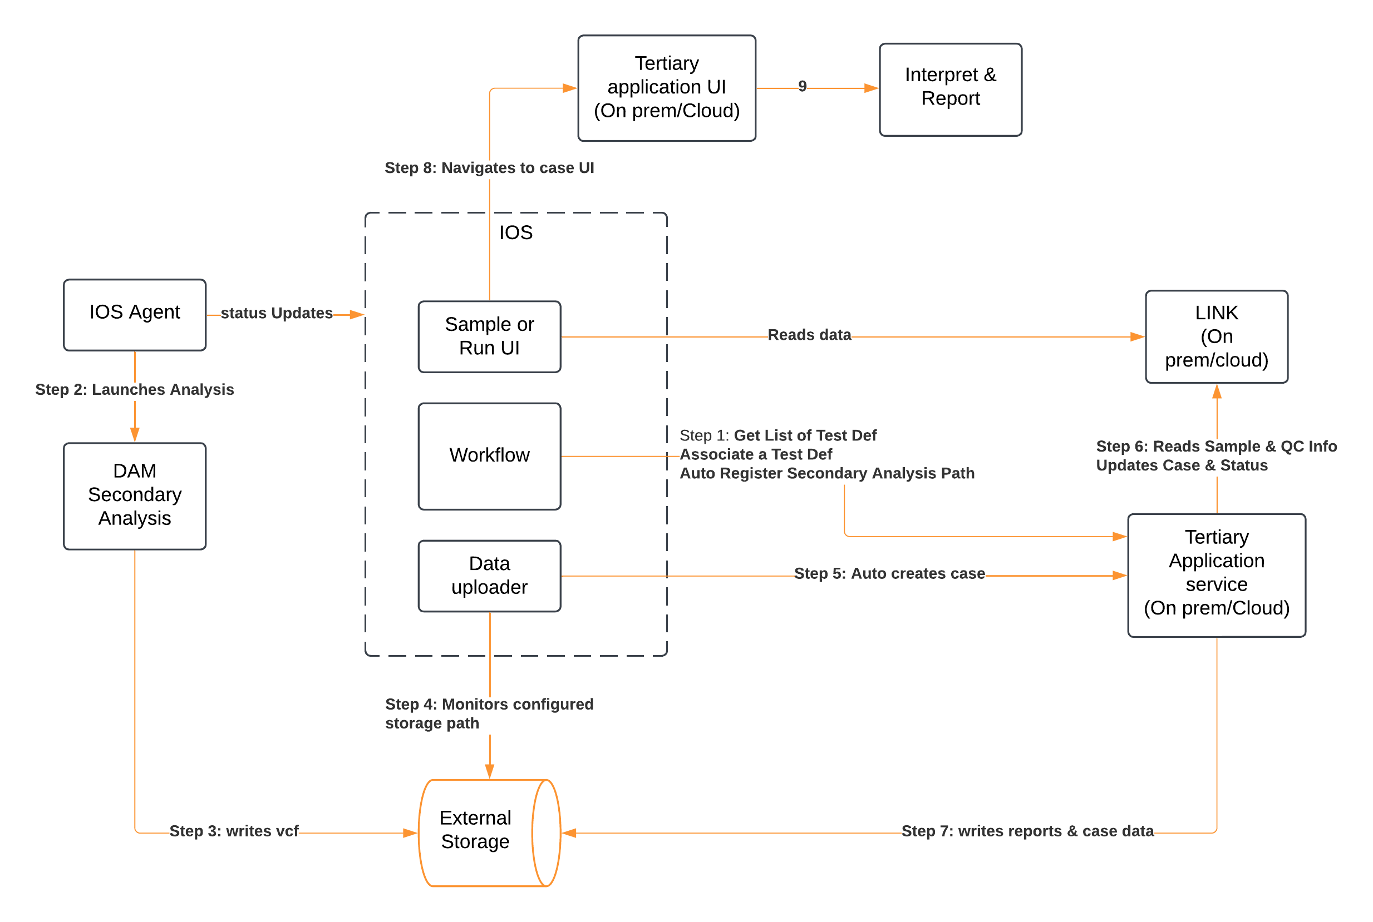

Logical Architecture – Authentication and Authorization
Interstellar Orchestrator software provides a central user management and auth capability. Once a instrument is connected with the IOS through an agent the agent will make a call to the instrument Auth provider service (e.g. EdgeOs IMS service) to register the path of the IOS application which will be used by the local auth service to make a call to the IOS to provide the Auth and to exchange the token. The local Auth service will register the token locally and provide access to the local application. If the local auth service is unable to establish a connection with the IOS it would display the error message on its user interface and will provide an option to the user to use local application login credentials. IOS can be registered with the LABS local Auth e.g. LDAP.

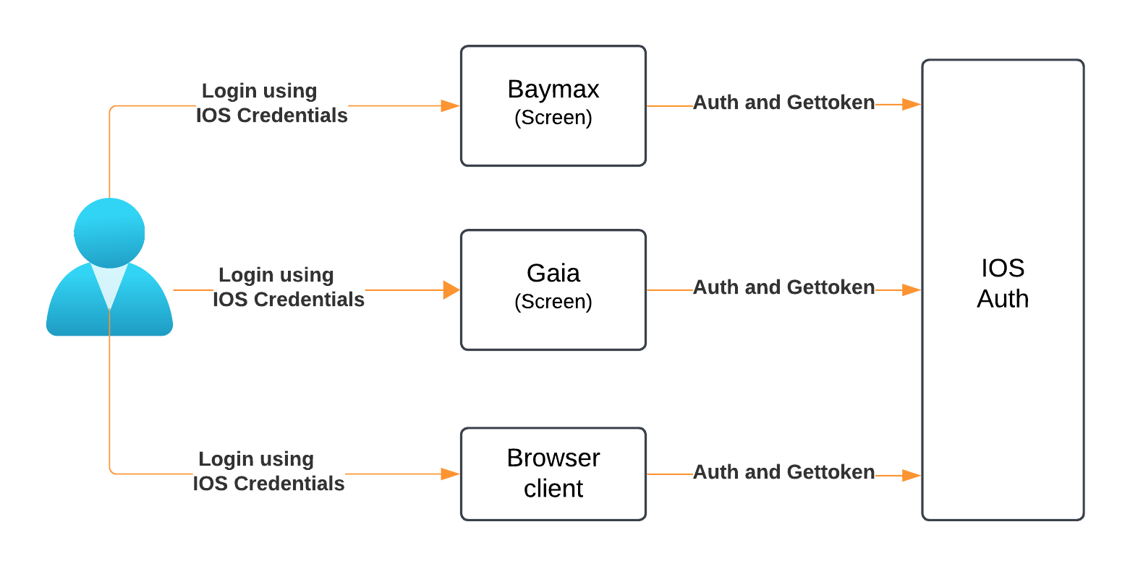

Logical Architecture – Third Party Integration APIs

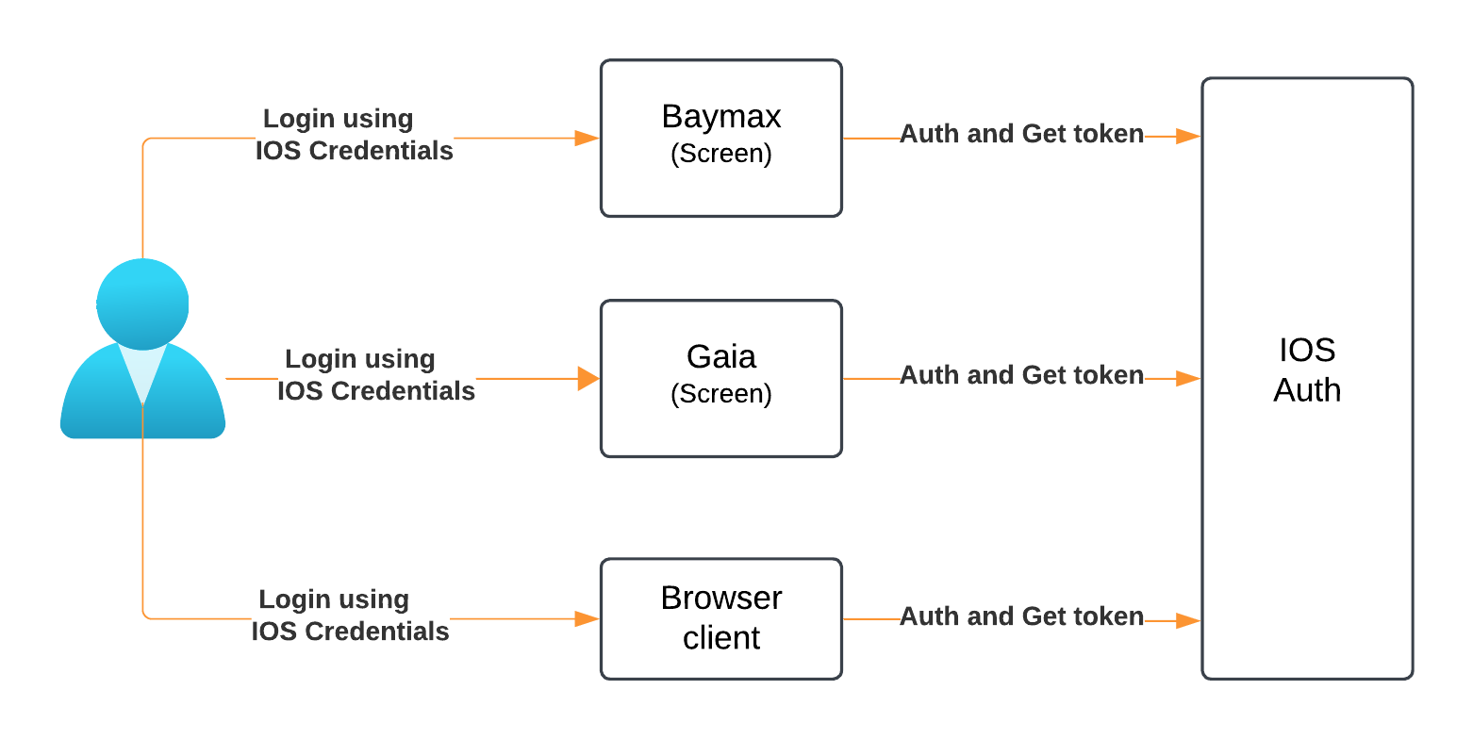

Logical UI Architecture
The IOS User Interface is built using Module Federation architecture where multiple separate builds show as a single application. These separate builds act like containers and can expose and consume code between builds, creating a single, unified application. This is often known as Micro-Frontends but is not limited to that.

The IOS Shell application (UI-Shell) acts as host, which is a JavaScript application that loads a remote UI Service when needed. A dynamic import is used for this or what some would call lazy loading. Webpack configurations are needed before getting to this step which is around routing.
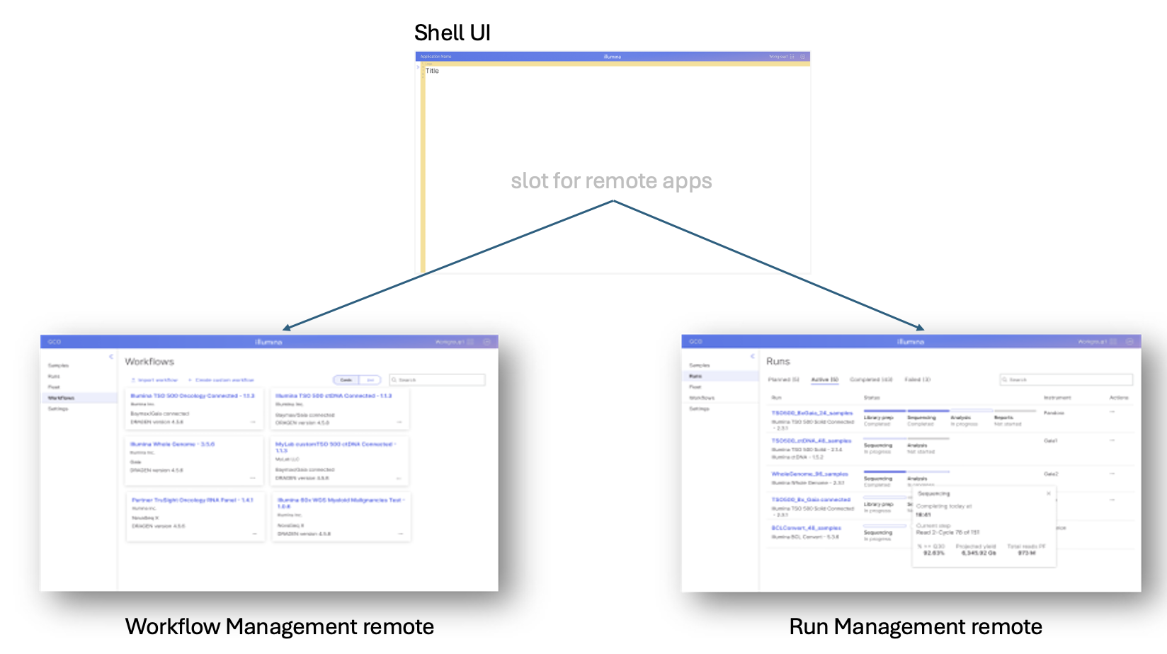

Security Architecture

System Level Security View
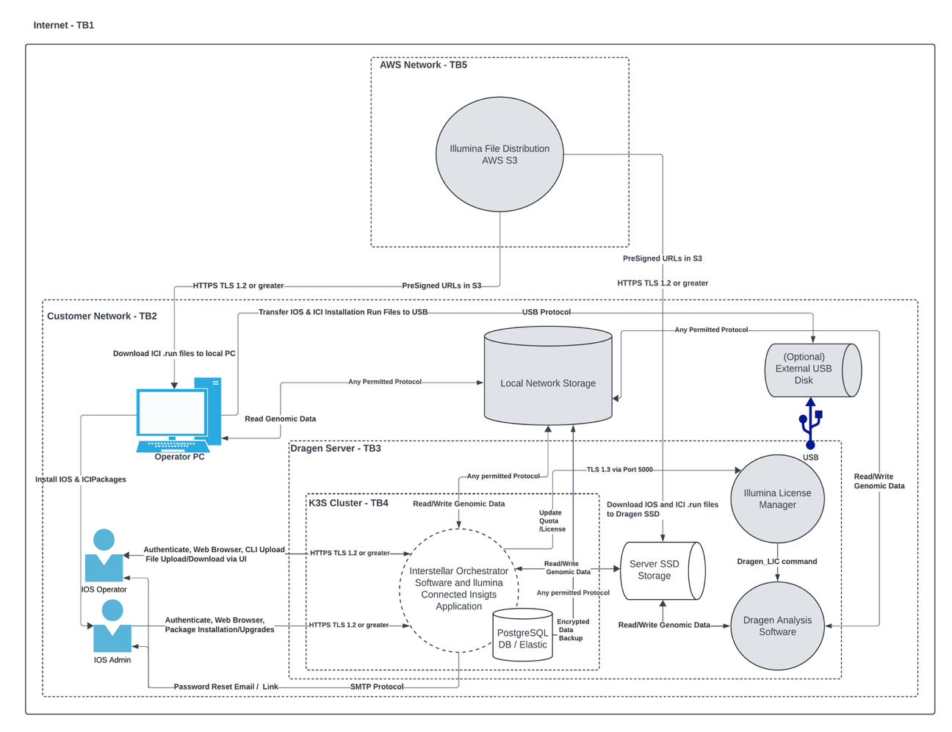

Component Level Security View(s)

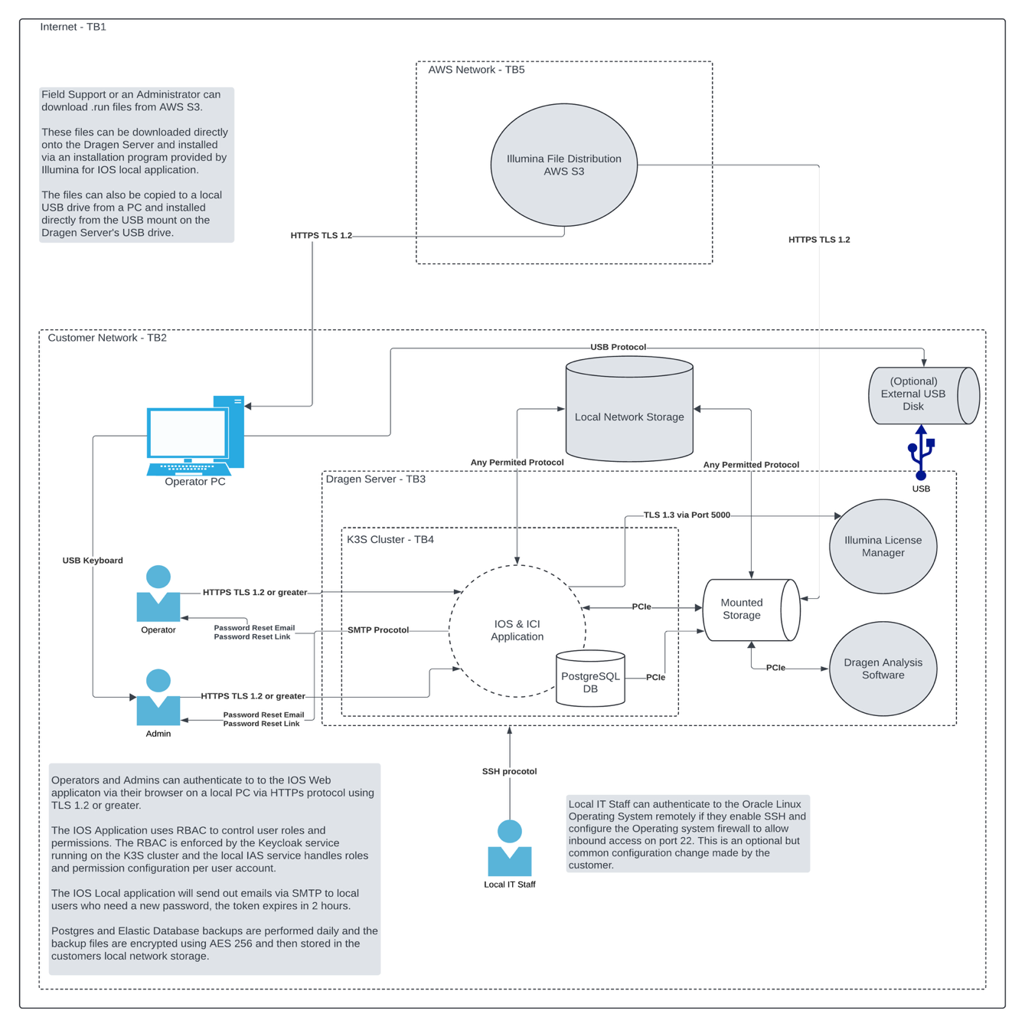

Multi-Patient Harm Architecture View

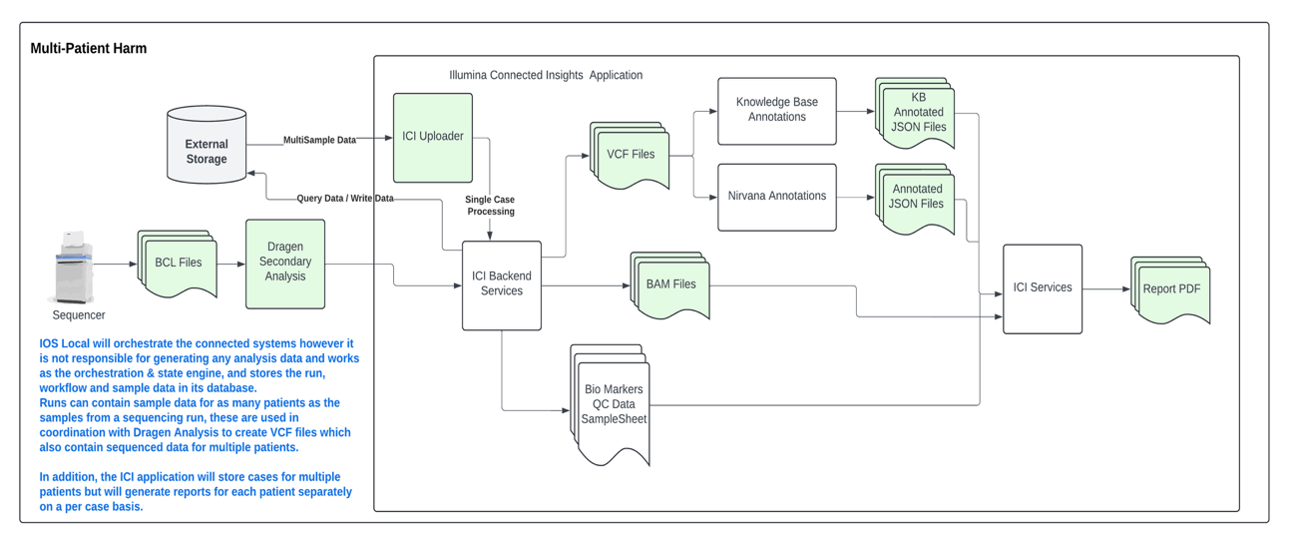

Software Decomposition
The software system consists of a set of UI Services that the user interacts with by navigating to the IOS application on their browser and Backend Services that hold the business logic for different aspects of the application. For additional details of each service in the architecture will be covered as part of the SDD’s.
Note: System is divided into SW units that are further indivisible refer decomposition diagram below:
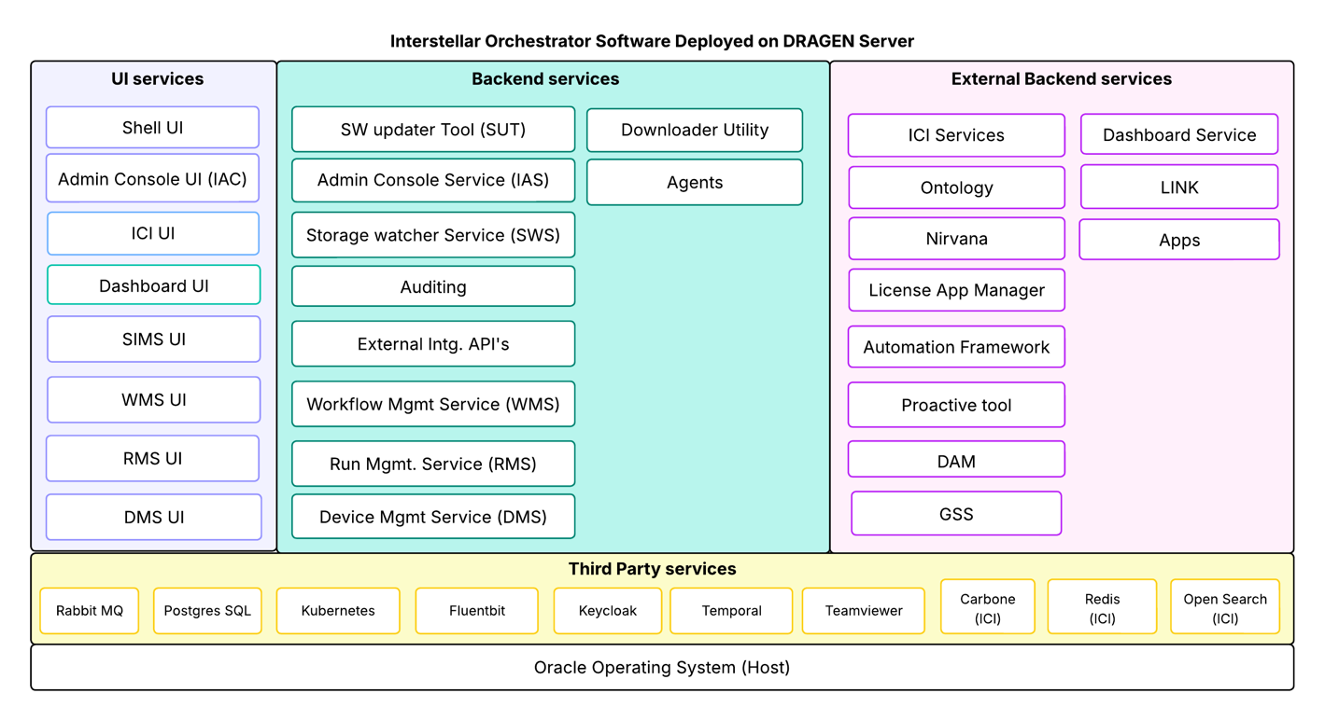

Type | Software Item/Unit | Description | SDD Reference
UI Service | Shell UI | A UI service that provides Shell framework to the IOS application UIs | 200029690
Backend API Service | Gateway Service | A service whose purpose is to authenticate and redirect traffic based on the user’s authorization | TBD
Backend API Service | API-Docs | A service to manage all the Swagger API calls in a single web page. The service will inspect all the public APIs from each service and present them in a single page for ease of use for user. | NA
UI Service | User management and Software Updater UI Service (IAC) | A Local service which allows user to update the software and manage Users and system policies and configuration | 200050533
Backend API Service | Local Admin console service  (IAS) | A service to manage the auth of the users of the Local systems | 200050533
Backend API Service/ Local Installer Updater | Software Updater Service (SUT) | A Local service to manage software updates  A script and service which manages the installation and updates to the software | 200050531
Cron Job of Kubernetes | Backup Service | A cron job of Kubernetes for ICI Local service to perform database backups | 200050532
Backend service | Local File serve backend service (FS-API) | This service is internally used by Local services to serve files from a pre-configured list of directories on the file system. | 200050915
External Services
Tertiary Analysis Processing | Illumina connected Insights | Tertiary Analysis and report generation application | Refer to ICI SAD (See References)
Secondary Analysis Processing | DRAGEN Application Manager | An application/tool which provides a installation and run time execution environment for the secondary Applications on DRAGEN server | Refer to DAM SAD (See References)
Infrastructure | Proactive Tool | Platform service that provides capability to track and manage sample usage for a domain | Refer to Proactive Tool Services SDD (See references)
Sample Store | Sample Information Management Service (SIMS) | Sample meta information and QC status management application | Refer to SIMS SAD (See references)
Automation | Automation Framework | Automation Management service which provides the language and tool to automate the workflow steps by configuration | Refer to Automation SAD (See references)

Software Classification
The classification of the top-level software system is Class A per the SDP.
All SW units decomposed in the Software decomposition shown in diagram 5 are independent units interacting to form the system and are classified as A as they lead to same risk level classification.

Software & Workflow Installation
The IOS local will be installed on a DRAGEN server on a Kubernetes cluster running each micro-service in individual pods. All the secrets will be dynamically generated at the time of installation of the software.
Below are the software packages required for supporting Sample to answer on premises solution
- Administration console package consists of a user interface for the admin activity, and it brings the local infrastructure and third-party services required for an on-premises deployment. E.g. services Admin console UI, User Management, Auth and Software updater utility. This is the package which will be installed by a FSE through the DRAGEN command line.
- Interstellar Orchestrator Software package brings all the features needed for IOS installed through the admin console user Interface
- Illumina connected Insights package installed through the admin console interface
The installation of the packages and status can be monitored through the user interface of the application. The IOS system will have an ability to fetch and download the packages from the illumina Support Site if the Illumina support site is whitelisted in lab and DRAGEN server has access to support site. The cloud fetch and notification can be enabled/disabled by the lab admin.
Individual workflow packages can be installed through the user interface of the workflow by a privileged application user.
The IOS local software and workflow installation supports below mechanisms
- Installation & updates using USB
- Installation & updates using external storage
- Installation & updates using Illumina cloud
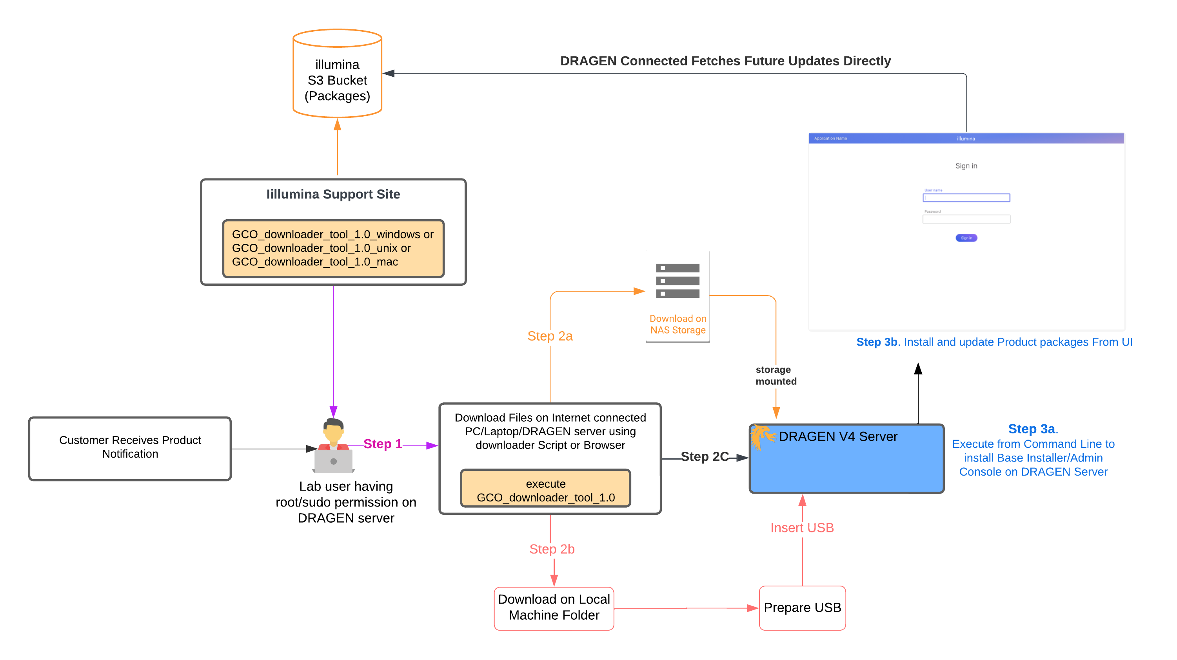

SOUP
Name |  |  | Description
Kubernetes |  | Kubernetes is an open-source container orchestration system used to automate the deployment, scaling, and management of containerized applications. It essentially acts as a super-efficient manager for containers, allowing you to group them into logical units for easier management and discovery
Keycloak |  | Keycloak provides user federation, strong authentication, user management, fine-grained authorization, and more
Fluentbit |  | A logging service
PostgresSql |  | A Relational database to store the information
Temporal |  | Temporal Workflows automatically capture state at every step, and in the event of failure, can pick up exactly where they left off.
RabbitMq |  | RabbitMQ is a reliable and mature messaging and streaming broker, which is easy to deploy on cloud environments and on-premises
Angular |  | Angular is a TypeScript-based free and open-source single-page web application framework.
Module Federation |  | Multiple separate builds should form a single application. These separate builds act like containers and can expose and consume code among themselves, creating a single, unified application.  This is often known as Micro-Frontends but is not limited to that.
Swagger |  | A standard format for defining APIs, ensuring structured and consistent endpoints, methods, parameters, and responses.
Java |  | Java programming Language
Springboot |  | open-source Java based framework to create microservice which allows to deploy the application.
Hibernate |  | Object/relational mapping (ORM) solution for Java environments. Automates object persistence to/from the database
Gralvm |  | GraalVM is an advanced JDK with ahead-of-time Native Image compilation. It accelerates application performance while consuming fewer resources, improved security, fast startup and compact packaging.
Liquibase |  | Open-source database migration tool
Walkme |  | A platform that integrates with Application to provide dynamic help and tool tips to the user for understanding the workflow steps and processing.
Traefik |  | It is a Kubernetes-native API Management solution for publishing, securing, and managing APIs, with support for multiple third-party ingress controllers
Cert Manager |  | SSL Certificate manager used for Local deployment.

Release History

Revision | Workflow | Originator(s) | Description of Change
1.0 | CN XXXX | Dhirendra Rai | Initial Release

